AcaWriter Quick Start Guide
Why is it relevant to you?
AcaWriter is a writing analytics program that can provide draft feedback on essays.

How does AcaWriter provide feedback?
In the same way that spell-check and Grammarly will indicate that there may be a spelling or grammatical error in your writing, AcaWriter indicates the presence of certain features of good academic writing. By simply copying and pasting text into the editor box on AcaWriter’s landing page and then clicking “Get Feedback & Save”, the software processes the text and reports back to the user whether or not certain types of text have been detected. AcaWriter does this with the help of sophisticated natural language processing technology powered by artificial intelligence.

So, what is AcaWriter looking for in your essays?
In short: attitude. In order to detect attitude, AcaWriter is programmed to recognise discourse markers.

What are discourse markers?
Good legal academic writing is an important skill for all lawyers. With the advent of evidence by affidavit, written submissions, email, and e-filing, lawyers write more than ever. Knowing how to write persuasively requires an understanding of the different functions that words perform. In your mid-session essays, you have been asked to take a stance in relation to a proposition. For example, should NSW Courts allow parties to appear and give evidence via video conferencing technology? To answer this question, it is necessary to evaluate the risks and benefits. Only an essay that takes a position and then provides a persuasive argument in support of that position will achieve a High Distinction. In order to persuade, the author should use particular rhetorical devices known as discourse markers. Discourse markers perform the function of speaking to the reader and conveying a position (e.g. This essay will argue …; It is interesting to note, ;Nevertheless, ; Conversely,…; However, …; In spite of these factors, …). More examples are provided in the reading material for Week 3 in UTSOnline.

Why bother?
Using AcaWriter gives students an opportunity to receive some pre-submission feedback about their essays. Where there are large tracts of text with no highlighting, students can ask themselves whether there should be (is some analysis, evaluation, original insight needed); or is there too much highlighting (which would suggest a lack of evidence and too much opinion)? Ideally, academics and tutors would give students this feedback, but there simply is not enough time.

Using AcaWriter also gives law students a practice-authentic opportunity to use cutting-edge technology that is used in law firms to analyse risk, sentiment, and relationships. For example, writing analysis enables predictive coding, which assists in the analysis of large data sets. For example, it may be used to determine whether documents or correspondence in the data set are relevant or privileged. It is important for law students to be exposed to technology that assists in document review so that in practice, they are able to appreciate how it works, know its limitations, and defend its use in Court.
A survey monkey form will be sent to you for your feedback on the writing activity and your experience on using the AcaWriter tool. Upon completion of this survey, you will receive a short text from Dr. Philippa Ryan to add to your CV on your contribution to the research on Writing Analytics.
Hear it from Dr. Pip Ryan as she explains it more in her videos.

How to use AcaWriter?
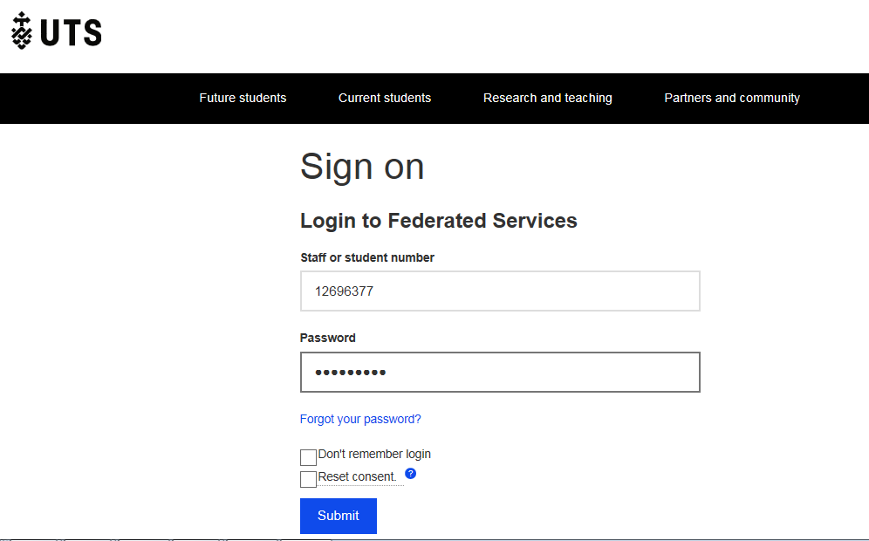
Open the AcaWriter website at https://acawriter.uts.edu.au. Select UTS Login and enter your UTS Student ID and password. This is the same ID and password that you use to log into UTSOnline.
Once you’re logged in you’ll see the My Dashboard homepage. You can Create a new document to experiment, but for Civil Practice related feedback, click Enter my assignment code and type: <assignment code>. This is matched to your subject (pops up in blue – see below). Click on this, and optionally edit the title of the new document you’re creating. Then press Add to my documents.

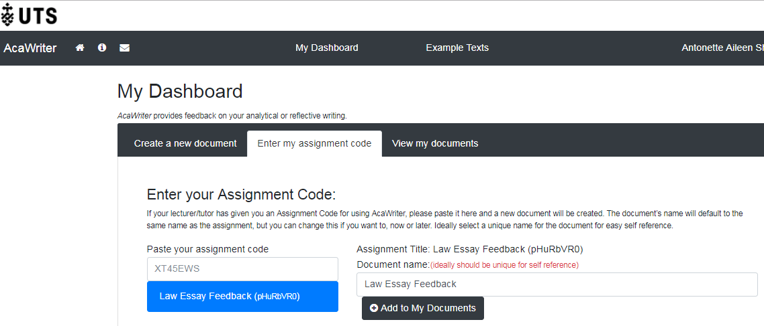
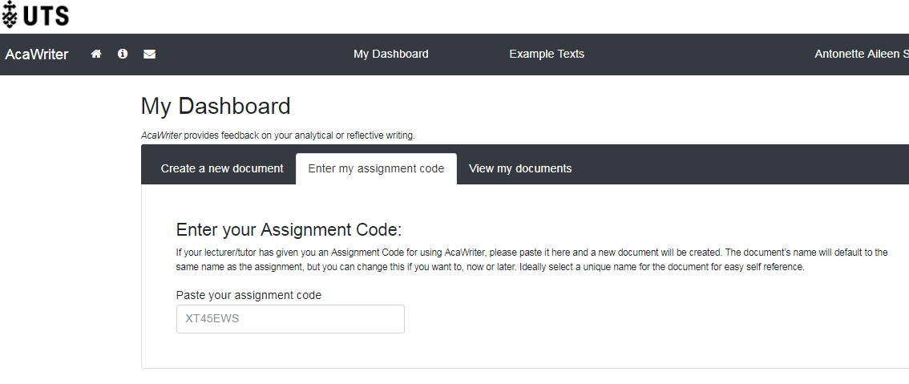

Click on Go to my document, or press the View my documents button and click on your Document Title. Your document opens, and you can now start using AcaWriter.

Paste your draft essay text into the white box and press the Get Feedback & Save button. AcaWriter works best with short texts, so paste only a section of text you’re working on to get feedback faster. AcaWriter will send your text to a server to be analysed and shows you the progress of the analysis. Once the server has completed processing, feedback from AcaWriter will appear on the right hand side of your original text.

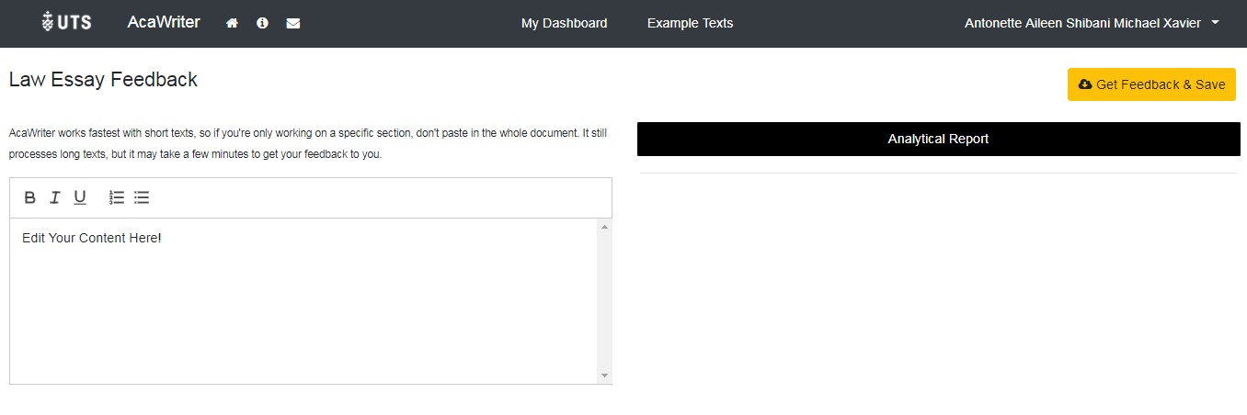
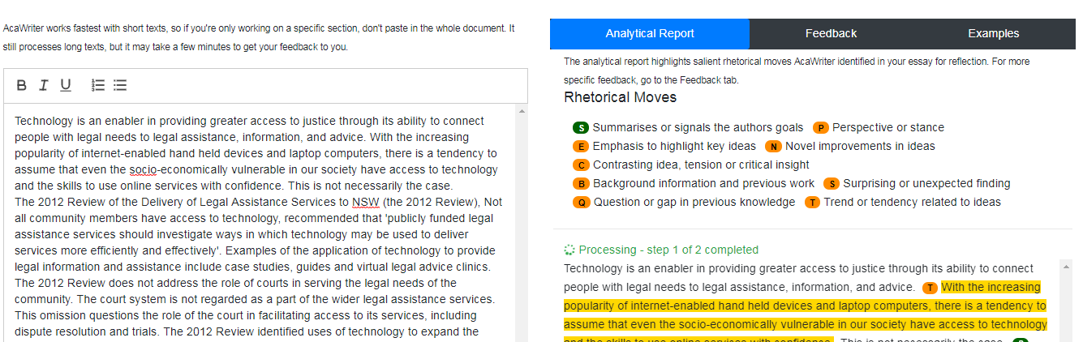

Feedback from AcaWriter consists of three tabs:

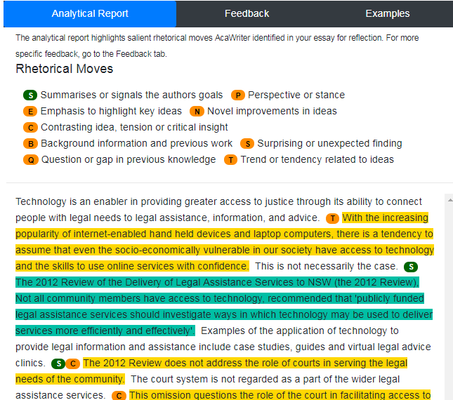

1) The first tab displays an ‘Analytical Report’ highlighting the key rhetorical moves AcaWriter identified in your essay. Reflect on this report to see if you have clearly expressed your attitude in the writing.

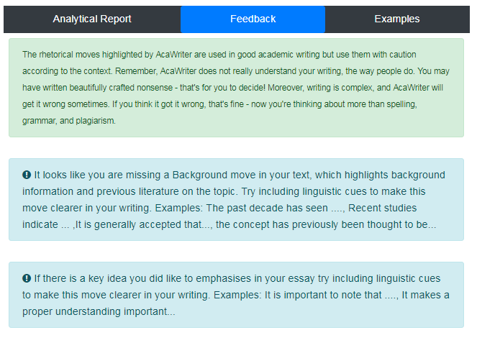

2) The second tab provides more specific feedback on the rhetorical moves you can include in your essay with sample discourse markers. These are not hard and fast rules, but by making the rhetorical moves visible, AcaWriter can help you think more on your writing.

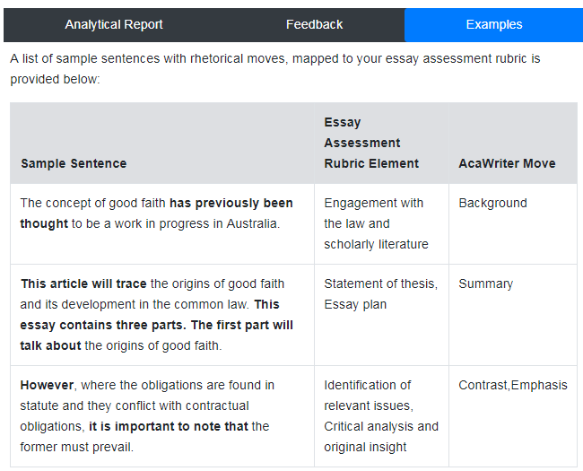

3) The third tab provides examples of rhetorical moves being used in sentences and are mapped to criteria from your essay assessment rubric. It shows how these moves can help you write better relating to your essay assessment criteria.

You can use AcaWriter feedback and edit your text directly on the left, and then request for feedback again. This feature allows you to make changes to see if your AcaWriter feedback changes accordingly. Making these kinds of edits in response to feedback can help you be more thoughtful about your writing. However, don’t fall into the trap of changing words just to get more annotations in your text. More annotations are not necessarily better. The true test of quality of your writing is that it meets the requirements of your subject assessment outline.

AcaWriter is a research tool which is constantly getting improved, so hang tight and let us know if something went wrong. Remember AcaWriter is just a tool for reflecting on your drafts. The only text that will be assessed is what you finally submit through UTSonline.

Now go ahead, try AcaWriter and write better!

